### Deliverables

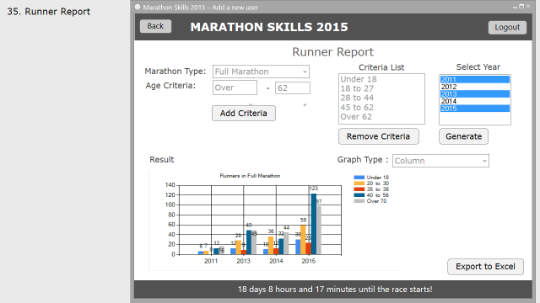

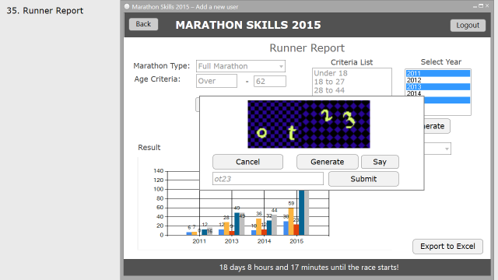

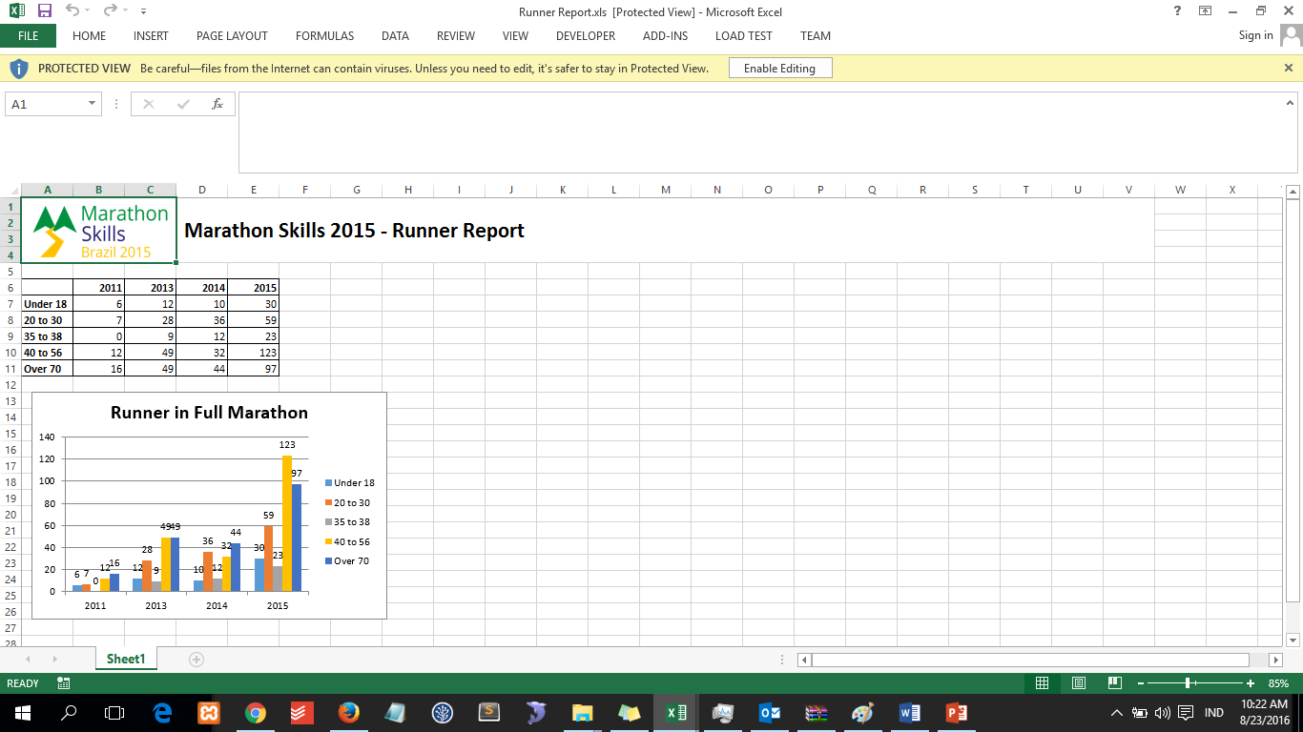

|  |
| --- |
| Create “Runner report” |
| Create the report form as outlined in “Runner Report” in the wireframe.  This form allows an administrator to get numbers of runner based on age group and marathon year.  The administrator can filter the summary data based on marathon type from database, age criteria list, and multi selection marathon year.  The administrator can create age criteria list which the minimum age range must less than maksimum age range and there’s no collision for each criteria. System will show proper message when user clicks ‘Add Criteria’ if the inputed criteria violate the rules. Age criteria consist of two combobox : first combobox contains “Over”, “Under”, and number between 18 -60 ; second combobox contains of number between 18 until 70. The administrator can add new criteria up to 5 criteria. System will sort age criteria list ascendingly after administrator add new criteria. |

|  |
| --- |
| Create “GENERATE feature”: RUNNER REPORT |
| When a user clicks the “Generate” button, provide a graph of summary data on windows form based on selected Graph Type (column or line form type) along with proper title, legend, and data label.  Before the program show the graph, application will make sure that at least 1 year has been selected and age criteria list is not empty.  When user clicks the “Export to Excel” button, program will show pop up window that show captcha image with conditions:   1. generate captcha random 4 – 6 character consist of alphabet A-Z, a-z, number 0 – 9 and symbol ($@!*&) 2. every character in captcha can have different font family (generate randomly) 3. every character in captcha can have different degree (0 to 30 degree of tilt) 4. captcha have random background that have different pattern (not just change the color)   The administrator can also hear the captcha character by click “Say” button. The administrator can also re-generate captcha image by click “Generate” button on pop up window.  The administrator can get excel file by click “Submit” button. However, the administrator need to filled in the same character on captcha to get excel data.  Excel File will show ( refer to wireframe ):   1. Proper Title & Marathon Logo 2. Table : show runner number matrix of age criteria (as row) and year group ( as column) along with proper border. 3. Graph : show same graph on windows form. |